Renju lesson on October 26, 2000

Hello! Welcome to renju class!
Last week we finished with i1 opening. Today we can begin with learning a new opening. But before that we can discuss one game. I want to discuss about the latest Japanese game - Nakamura vs Hasegawa in Japanese Meijin Match. It was played two weeks ago. It was the first game of the match. The rest of the games will be played later. In the first game, Nakamura played as black. Opening d3 was chosen.
Hasegawa played usual 4th move. Do you know which one? Yes, 4-i9.
I guess you have all played this opening before, and you know this is the most balanced opening in renju. Is here anyone who remembers my games with Nakamura? The 3rd and the 6th game? If you do, then you also remember the 9th move I played against him. This time he chose the same 9th move against Hasegawa.
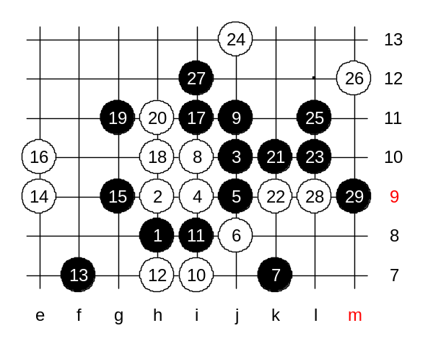
The 5th move is j9, of course. White 6th is j8. As you know, the 5-g9 is the best choice for black and therefore white seldom lets black play it. Even in case of 5-g9, black has an advantage, but it is not dangerous if white plays correct moves all the time. Move 5-j9 is just one of the alternatives. In fact, this opening has lots of possible 5th move. Although I have played this opening for years, I still do not know what is the second best 5th move. Sometimes one 5th move is popular, sometimes another. If you want to know which 5th moves are possible here, then I can list them for you right here. The possible 5th moves are g9, i8, j8, j9, k9, i10, i11.
Sometimes people use other 5th moves, too, but they are not correct and white should win in those cases. Nakamura chose the 5th move because he wanted to try something new, I think. Obviously he had done lots of analysis after the match with me last year, and he must have found some good development ideas for black there. Move 7-k7 is well known move. White's standard answer is 8-i10. That was also Hasegawa's choice. All the old renju books tell about 9-i11 - it is the traditional Japanese theory that ends with white advantage. Move 9-j11 is quite new move. That is why you cannot find any information about it from any books. I think it was discovered by some Russian players. Of course, at that time the move was played in small tournaments and among weaker players. The world top players did not know much about it. At the moment, this is the most interesting position in recent renju theory. And it is surely the most analysed variant in past 11 months. People all over the world have tried to search for the answers here. They want to know the conclusion of the variant. They want to know if it is good for black or good for white. I have analysed it maybe over 50 hours, and I still do not have the answer. I remember, before the match with Nakamura I thought this variant will end up with black advantage. After the 6th with Nakamura game I though this is really good for white. During next couple of weeks later I changed my opinion 4 times. I wrote an article about "white win". Later I discovered a serious bug in my analysis, and it totally changed the evaluation, I wrote another article about "black win" there. And I changed my opinion two times after that. Right now, although I am probably the most competent player in the world about this variant, I still do not have final conclusions. At the old times, move 10-i7 was used in all games. And Hasegawa chose it against Nakamura, too. After the match with Nakamura I raised an issue of 10-g11. It is really active move, and it seems that the draw is out of question in that case - either black or white wins after such active 10-g11. Both Nakamura and Hasegawa were aware of it. The variant of 10-g11 is very important. I explain why. If... I mean IF white wins after 10-g11 then the 9-j11 is a mistake and should not be used. Nakamura still chose it. Does it mean that Nakamura had analysed all the variants of 10-g11 and made sure white cannot win there? I know it was so hard and time consuming work to make sure the result of 10-g11. And I also know that my "black win' article has some bugs, too. But nobody else knows about it except me, because I have not written any article after that. I am already very close to the truth, but still many things need more analysing. Now, back to the game. My guess it that Nakamura does not know the 100% truth about 10-g11. I guess that Japanese have seen my analysis of "black win". And Hasegawa has seen or heard of "black win". An Nakamura took advantage of it. It is simple psychological trick - to manipulate with common opinion. Nakamura knew that Hasegawa would not choose 10-g11 no matter what. That explains the risk Nakamura took with playing that 9th move. As the 10th move was played to i7, the following moves were obvious, too. We can call these 13 moves as the first theory of this variant, and it is still popular as you can see. Hasegawa choose 14-e9 instead of traditional 14-f9. As you know, this game was played in October (this month). As you also know there was team world championship in May this year. All the world top players joined the team world championship except Nakamura and me. And whatever those top players play in their games, are serious and getting attention. Move 14-f9 was played several times there, and black won in almost every case. Hasegawa was also in the team world championship. He saw the "problems" of 14-f9 there, and probably decided to change the 14th move because of that. Yes, move e9 is a new move. Move 15-g9 - calm and simple. Black stone at g9 connects with point j12 and white has to take this into consideration. However, 16-f8 is not a good solution because of 17-k9. And passive 16th move around j12 is not good either - in that case black can slowly build up the attack on the right side. Therefore Hasegawa risked and played an active 16-e10. How about 16-g11, you ask. Well, I think in that case black can also play 17-k9. Am I correct? After Hasegawa's 16-e10 black simply attacked and won. Let's see how it happened. Move 17-i11 - a natural beginning of the attack. That also explains the idea of 15-g9. Yes, 18-h10 now. The 21st move was the key move of the attack. Hasegawa must have counted on controlling the black's diagonal line from h12 or g9. But he miscounted that black can also attack without using that line. Finding such 21st move requires a skill of counting possible VCF threats and possible cuts that white could create. 21-k10 - that's the win. Can you see black's VCF threat here? Good. Can you see black VCF threat if white plays h12, g10 and i12? Yes, Lu, correct VCF. Therefore, Hasegawa had no choice but defend passively at k9. After 23-L10 black has another VCF threat. Do you see it? Yes, there are even two kinds of VCF threats. Therefore Hasegawa played 24-j13. The following black moves are simple. Where is the 29th move? Yes, 29-m9 was the last move in that game. White resigned after that. Black has 4x3 threat in both k11 and n10. This was the first game of Meijin Match 2000. The next games will be played soon, too. Meijin Nakamura will need 2.5 points from 5 games to defend the title. He already got one point now. We can wait their next game with excitement.
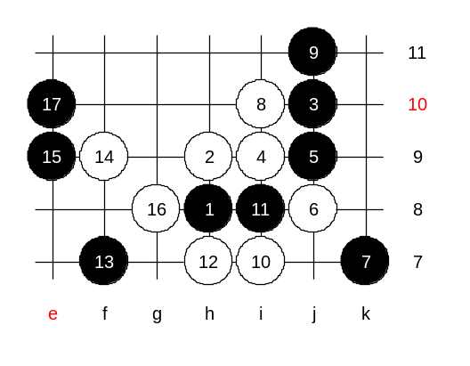

We end our today's lesson with homework question.
Medium level homework: please find the white win.

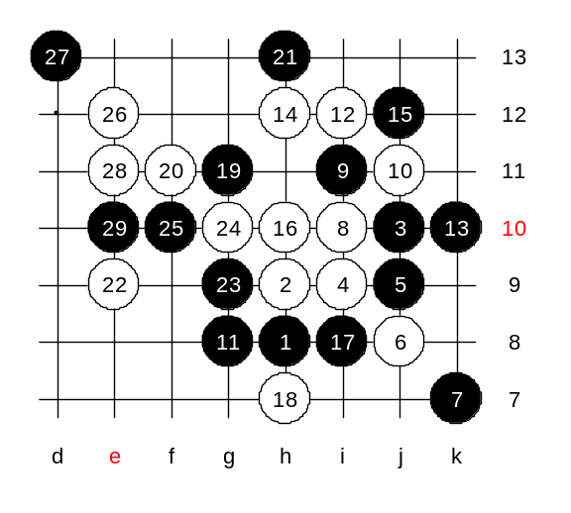

Advanced level homework: please find the white win.

